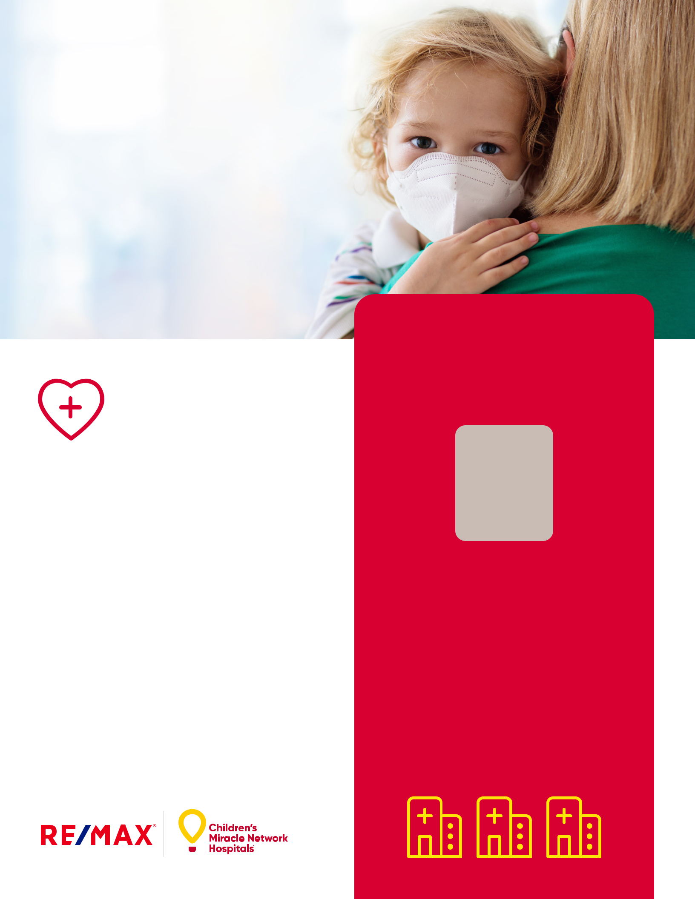
Change Kids’ Health. Change the Future.

Giving back in
our community.

Children’s Miracle Network Hospitals® raises funds and awareness for 170 member hospitals that provide more than 10 million treatments each year to kids across the U.S. and Canada.

Since 1992, RE/MAX® has raised more than $185 million to help change kids’ health and change the future.1

Enter specific information about local office events/involvement-

Aperiberis ea et is aped exerspiet as dicatis exerum eicimus pa dolum aut doluptaspis volora corio explamet ma dolendu ntiati cum eium quis voluptur apeliti occumquibus, estorectur, neturi ut

I’m a Miracle Agent

Supporting [enter local

hospital name here]

AGENT NAME

Agent Title

- 555-1212 (label)

- 555-1313 (label) email@remax.com
www.remax.com
RE/MAX Office Name

1234 Main Street, City, ST 00000

License #

Each Office Independently Owned and Operated.

22_304239 Disclaimer 2.

1U.S. and Canada combined.

To learn more visit cmnhospitals.org.

